Practical 4
Question:
Write a C program that creates multiple child processes (three) in a loop using fork(). Each child should display its own PID, sleep for a different duration, and then terminate. The parent process should wait for all the child processes to complete before exiting.
Code:
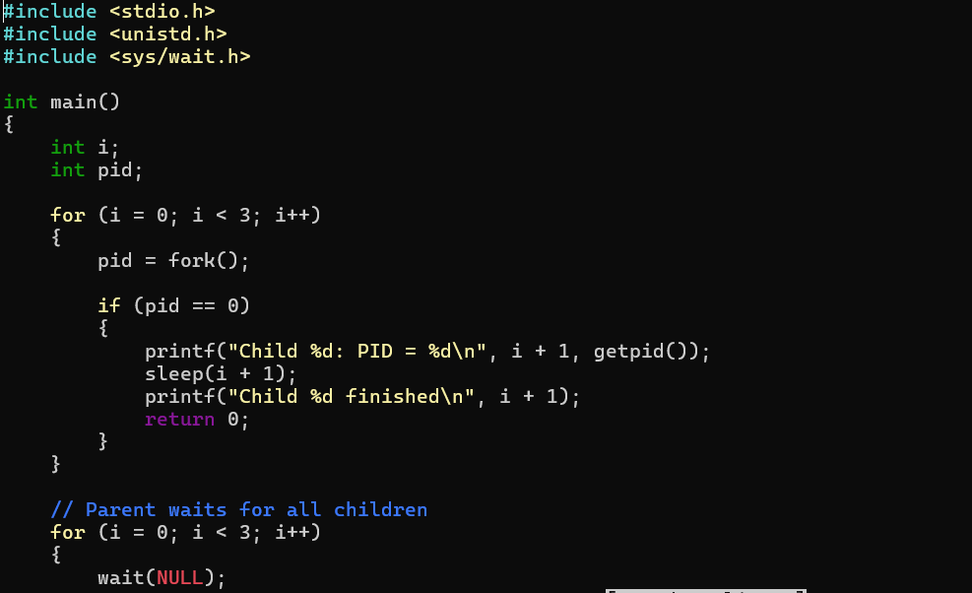
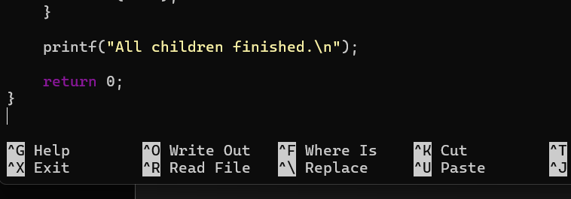
Output:
